WEB TECH EXP – 241801020 – ANDRYAN DURAI JEBIN
OUTPUT –
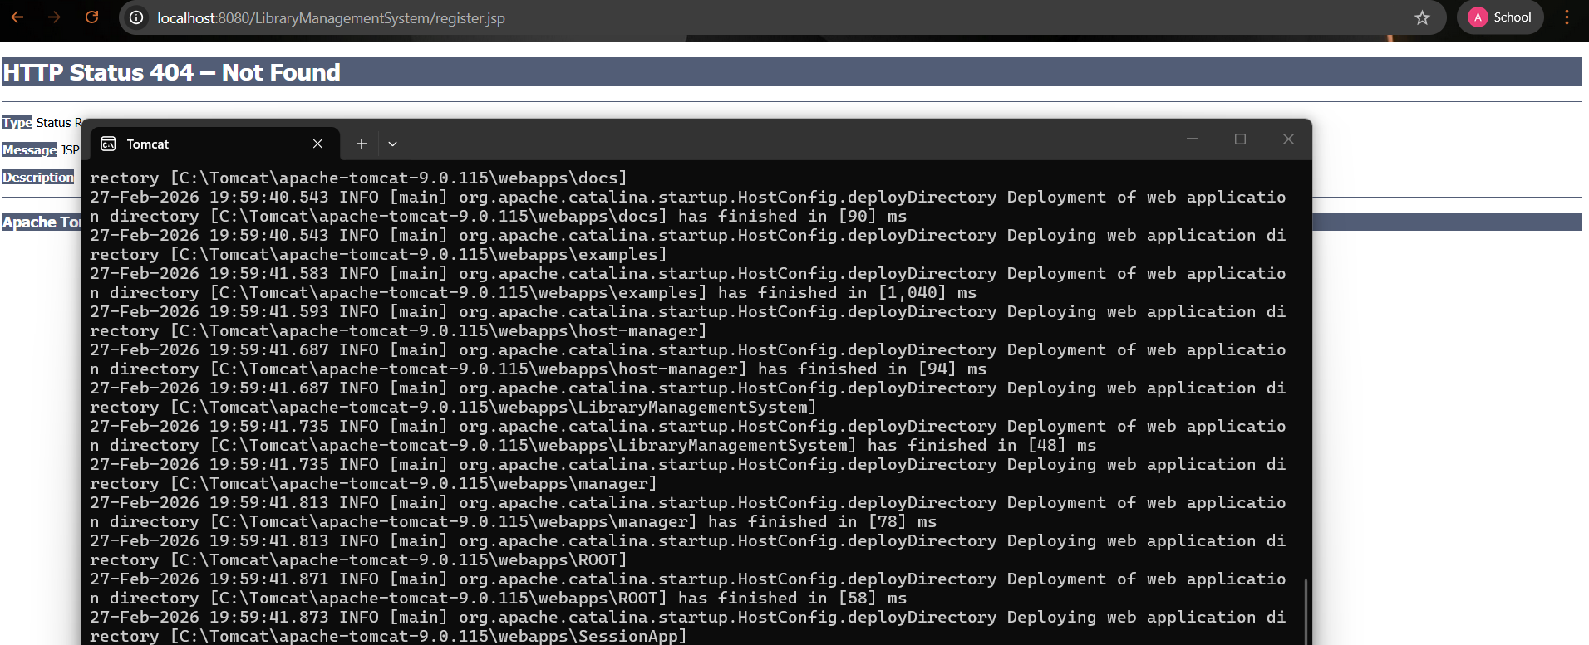
PROGRAMS –
